

IT313 - Software Engineering

Parking Management System

Group No. 29

# GUI Testing

Group Members

202201431 Heet Thakkar 202201407 Herik Patel

202201417 Vats Shah 202201409 Ramya Shah

202201418 Dev Soni 202201401 Vraj Patel

202201448 Neel Vasoya 202201436 Stavan RaviSaheb

202201415 Darshan Jogadiya

Under the guidance of: **Professor: Dr. Saurabh Tiwari**

Mentor: Jaydeep Darji

Web Pages:

1. Home
2. About us
3. Sign up
4. Login
5. Forgot Password
   1. Reset password
   2. Set new password
6. Profile
7. Contact
8. Booking
9. Feedback
10. Admin Dashboard

Using Selenium:

1. Contact Us

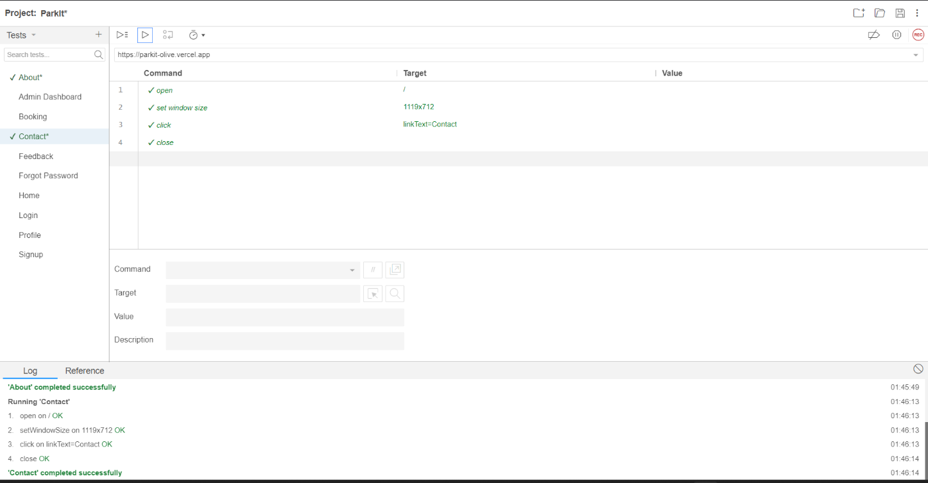

1. About Us

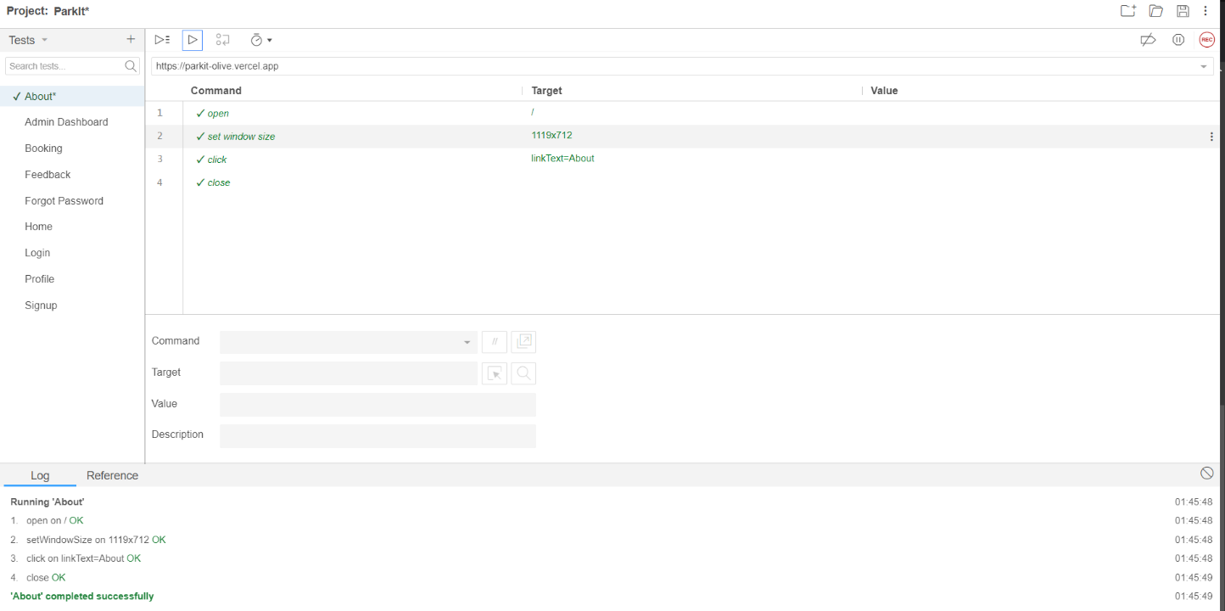

1. Sign Up

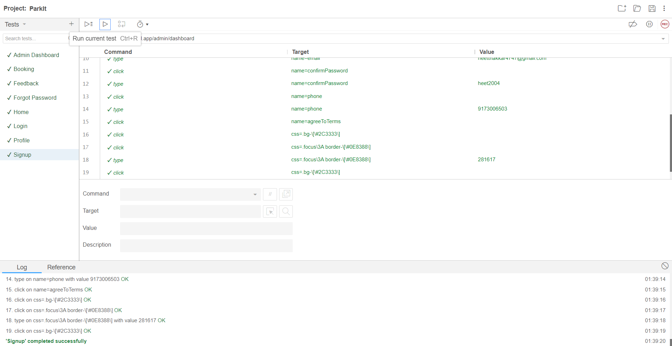

1. Profile

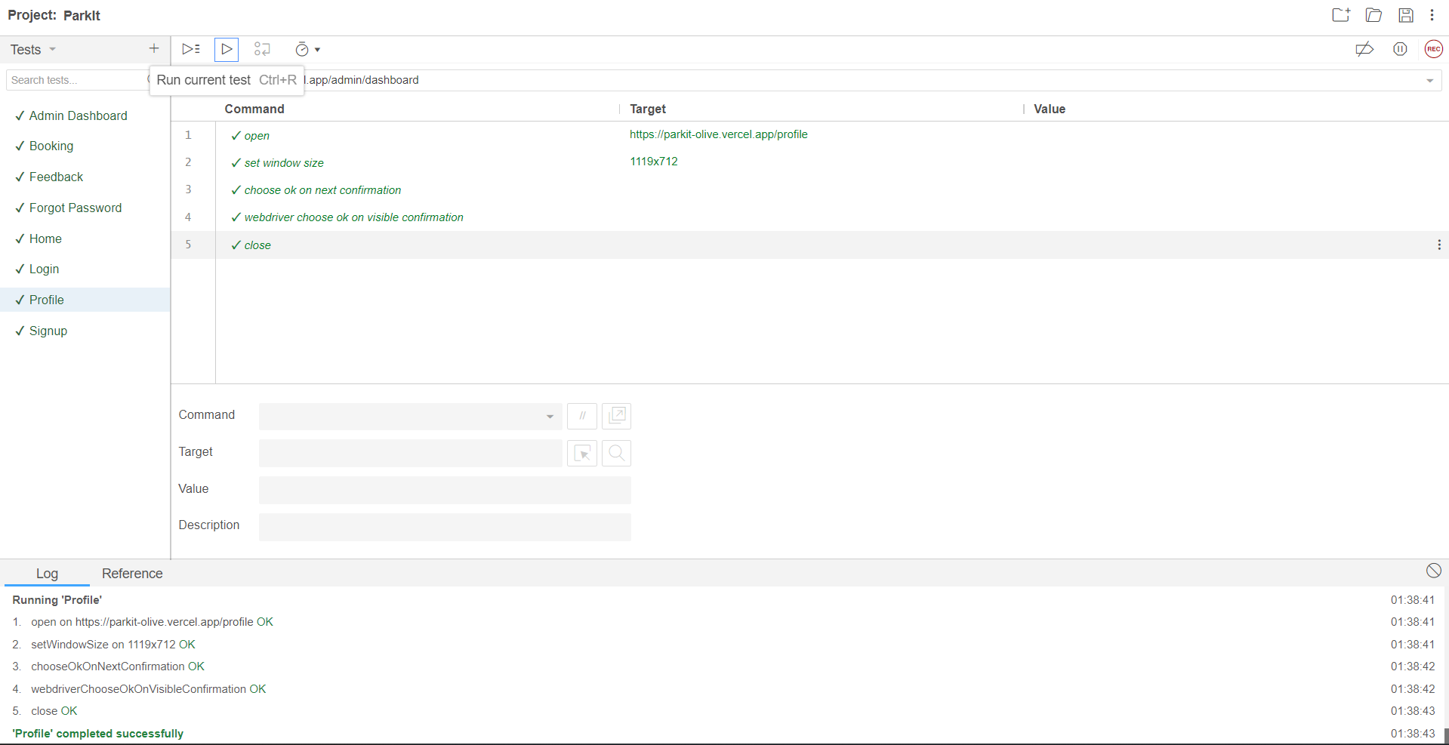

1. Login

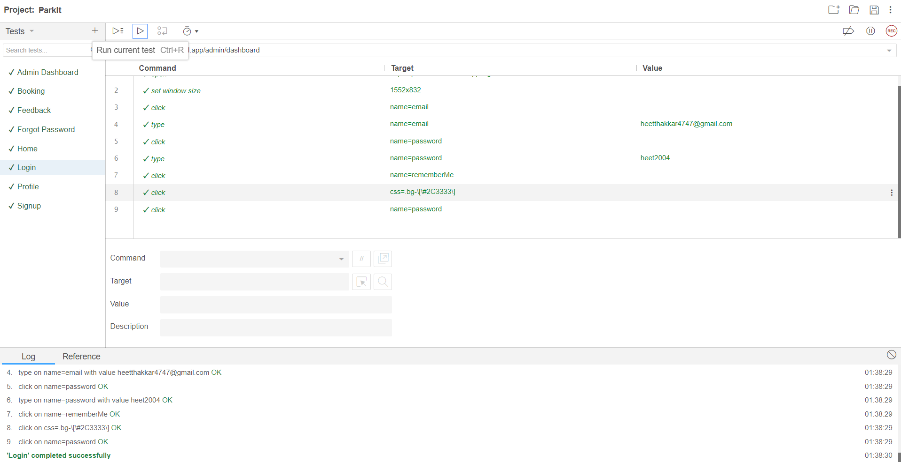

1. Home

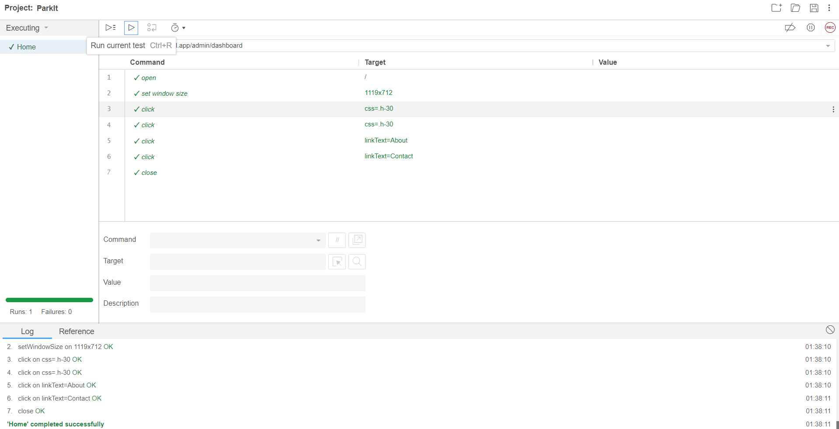

1. Forgot Password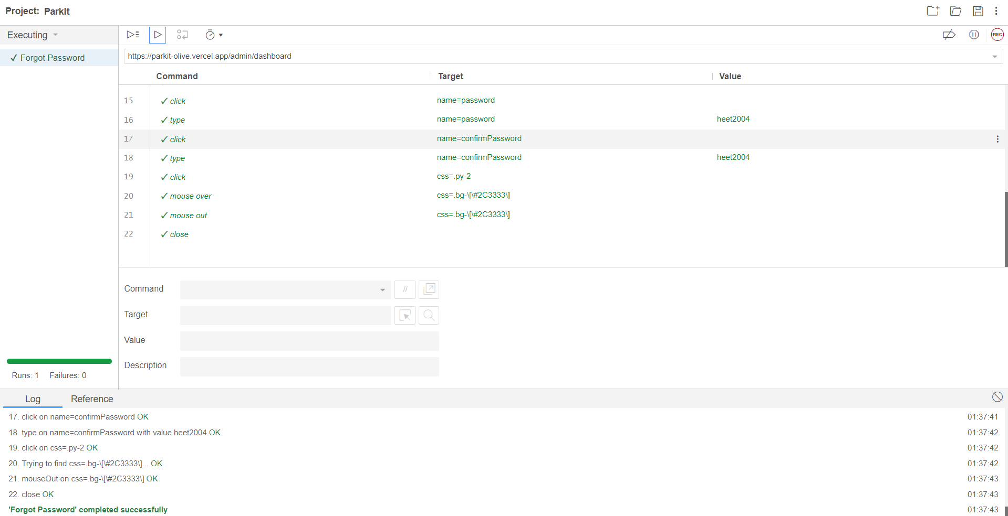
2. Feedback

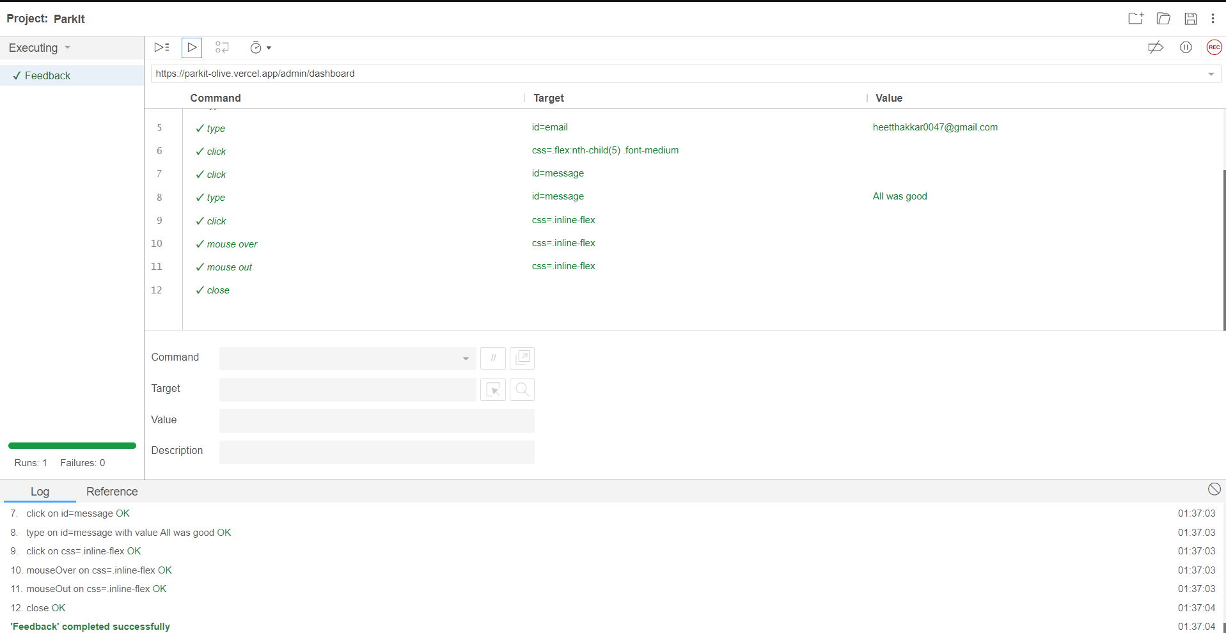

1. Booking

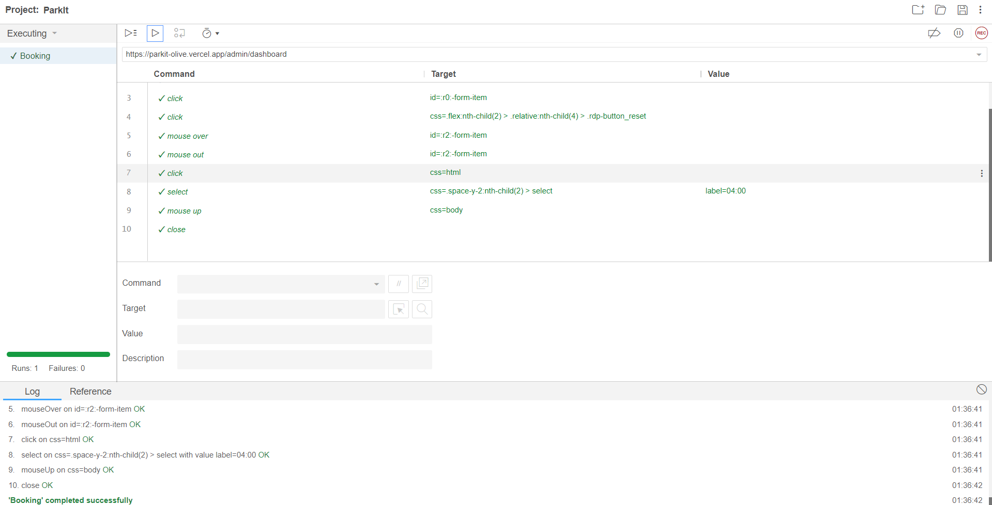

1. Admin Dashboard

